Performance Monitoring
Mrs. Donovan

October Assessment

Mrs. Donovan teaches many children who have an Individualized Education Program (IEP). On a daily basis, she works with her teaching assistant. During the week, she also works with the Speech and Language Therapist. In order to plan instruction for all the children, Mrs. Donovan and her team administered a Curriculum Based Assessment in October. They used the Assessment, Evaluation, and Programming System for Infants and Young Children (*AEPS). To complete the AEPS, she gathered information about all children during daily activities, interviewed familiar caregivers, and conducted authentic assessment activities as needed. All children’s performance was documented using numerical scores and placed on the AEPS data recording form. Notes were also taken and written on the form.

AEPS - October

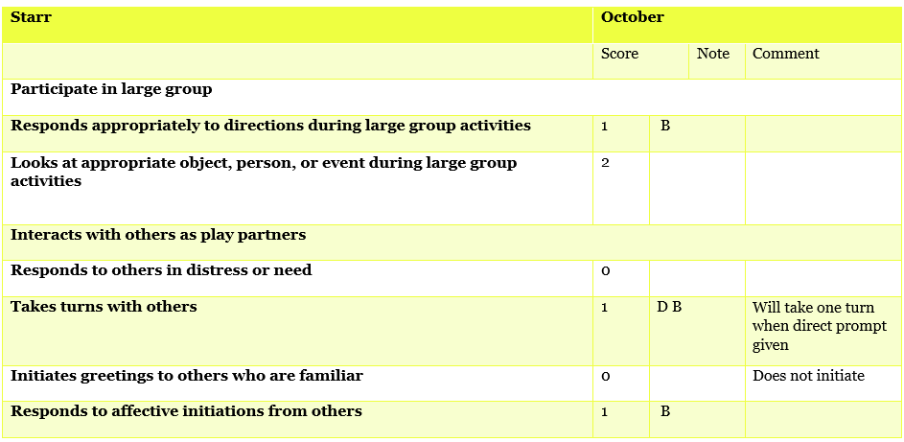

Ratings
2 = Child independently and consistently met item criteria
1 = Child partially met specified criteria, child needed assistance, child inconsistently performed the criteria, and/or, the child’s performance toward the criteria was emerging
0 = Child was not yet able to perform or meet the stated item criteria

Notes
Q = Quality of the Child’s performance is a concern
B = Child’s behavior interfered with his/her performance
D = A Direct Prompt was needed for the child to perform the task

Activity:
-Determine a goal for Starr based on the October assessment results.
-Next, determine the data collection methodology to use. How often would you collect data on this skill?

Visual Summary and Patterns

Mrs. Donovan created a visual summary of the entire class’s performance across all of the items on the AEPS. She identified the percent of items achieved, emerging, and not yet demonstrated for each child for each major area of the AEPS.

Below the table depicts the percent of AEPS items achieved in the area of Engaging in Cooperative Activities.

Engaging in Cooperative Activities, Total = 10 items
Name | % of AEPS items achieved | % of AEPS items emerging | % of AEPS items not yet demonstrated
Starr | 40% | 30% | 30%
Jamel | 30% | 40% | 30%
Jamie | 40% | 40% | 20%

Activity:
-Is this a goal you would target for the whole class?

Mrs. Donovan identified several goals for Starr. She knows she is going to work on her taking turns with her peers because this is a priority for Starr’s family. Starr has a sister and Starr’s family would like to see her engage with her sister and take turns. In addition to this goal, Starr will work on initiating a greeting during a cooperative activity. She can say hello, want to play, or any other age appropriate greeting.

Mrs. Donovan began providing instruction on the goal and collected data during three activities (small-group centers, large-group circle, and outdoor play).

She documented when Starr initiated a greeting by putting a + on the data sheet. If Starr did not initiate a greeting during the activity she placed a - .

She collected data one time per week. Mrs. Donovan would like for Starr to initiate at least one time during each activity.

 | Large Group Circle | Small Group Center | Outside
11/10 | _  cried and grabbed items from peers | ++ | _
11/17 | +++ | - | _
11/24 | _ | +++ | _
12/1 | ++++ | +++ | _
12/8 | _  cried and grabbed book from peers | ++++ | _

Activity:
-During each cooperative activity, what percentage of time is Starr initiating a greeting with her peers?
-Review the data collected thus far. What patterns emerge? (strengths, lack of quality, assistance/prompting required, behavior interference, unexpected scoring sequence)
-Based on the data, would you make any changes to Starr’s instruction?

Visually Analyze

After reviewing the AEPS scores, Mrs. Donovan identified another goal for Starr and for Rosa. They will work on engagement.

Mrs. Donovan began providing instruction on the goal and collected data twice a week. Data is collected during small group centers. Mrs. Donovan would like for Starr and Rosa to be engaged 80% or more of the time. After several weeks of instruction, Mrs. Donovan takes a close look at the data.

 | % of time engaged | % of time engaged | % of time engaged | % of time engaged
Starr | 25 | 33 | 36 | 25
Rosa | 48 | 52 | 56 | 58

Activity:
-Review the data outlined in the table. Analyze the data and provide a summary.
-Based on the data, would you make any changes to Starr’s instruction? To Rosa’s?

Tier 1, Tier 2, and Tier 3

Mrs. Donovan has the AEPS results for her entire class. She identified the percent of items achieved, emerging, and not yet demonstrated for each child for each major area of the AEPS.

Below the table depicts the percent of AEPS items achieved in the area of Letter Awareness and Vocabulary. Mrs. Donovan will work on letter awareness and vocabulary development every day in her class. She considers these skills to be Tier 1. She uses the AEPS results to determine areas of need for her students who may need Tier 2 or 3 level support.

Letter Recognition
Name | % of AEPS items achieved | % of AEPS items emerging | % of AEPS items not yet demonstrated
Starr | 70% | 20% | 10%
Jamel | 80% | 10% | 10%
Jamie | 40% | 20% | 40%

Vocabulary
Name | % of AEPS items achieved | % of AEPS items emerging | % of AEPS items not yet demonstrated
Starr | 40% | 30% | 30%
Jamel | 80% | 10% | 10%
Jamie | 70% | 20% | 10%

Activity:
-Review the data outlined in the table. Do any children require Tier 2 or 3 level instruction?

Activity:
Using all the data you have available for Starr:
-Identify universal instruction
-Identify targeted instruction
-Identify individualized instruction

Your Students

Activity
Consider the group of children you taught this past school year
  - What assessment data did you collect?
  - What other data did you collect?
  - What skills do the majority of them need to know?
  - What skills do a small group of them need extra help with?
  - What (2-3) skills do individual children need intensive instruction on?

